**INTRODUCTION**

**About C**

C is a general-purpose high level language that was originally developed by Dennis Ritchie for the Unix operating system. It was first implemented on the Digital Equipment Corporation PDP-11 computer in 1972.

The C program starting point is identified by the word main( ).. • This informs the computer as to where the program actually starts. The parentheses that follow the keyword main indicate that there are no arguments supplied to this program.

**About PROJECT**

Our program consists of following functions/statements and each one of them is described briefly thereafter.

* Void
* Symbolic constant
* Printf( ).
* Scanf
* While
* If
* If else
* Nested if else
* Break
* Continue
* Return
* Switch
* Structures
* Functions

**VOID :** It represents a null value.

SYNTAX: void name ( )

**SYMBOLIC CONSTANT:** It is the name that will be replaced with their values when the program is complied. It will be defined before main ( ).

SYNTAX: #define NAME value

**PRINTF ( ):** It is used to display information on the screen.

SYNTAX: printf(“control specifier”,argument list);

**SCANF ( ):** It is used read.

SYNTAX: scanf(“format specifier”, address list);

**WHILE:** It is a loop which executes statements until the condition of the while loop is true.

SYNTAX: while (condition)

{

expression 1;

}

**IF:** It can execute either simple or a compound statement depending on the result of an expression.

SYNTAX: if (condition1)

{

Statement 1;

Statement 2;

}

Statement x;

**IF ELSE:** The statement executes a simple or compound statement when the conditional expression provided in the if statement is true.It executes another simple or compound statement ,followed by the else statement ,when the conditional expression is false.

SYNTAX: if (condition 1)

Statement 1;

else

Statement 2;

Statement x;

**NESTED IF ELSE** : When a series of decision’s are involved nested if else statements are used.

SYNTAX: if (expression 1)

else if (expression 2);

else if (expression 2);

…………………….

else (expression 6);

**BREAK:** It is used to come out of the current loop.

SYNTAX: break;

**CONTINUE:** It is used to terminate the current iteration.

SYNTAX: continue;

**RETURN:** It is used to return the values.

SYNTAX: return;

**SWITCH:** It is the conditional statement that tests a value against different values.

SYNTAX: switch (expression)

{

Case 1 : block 1;

Break;

Case 2 : block 2;

Break;

……………..

Default : default block

Break;

**STRUCTURES:** It refers to a user defined data type that contains variables of different data types grouped under a common name.

SYNTAX: struct structure name

{

Data-type_1 variable_1;

Data-type_2 variable_2;

……………..

Data_type_n variable_n;

}

**FUNCTIONS:** It is a function which contains actual code that performs the intended task.

SYNTAX: function type function name (parameters list)

{

Local variable declaration

Statement 1;

…………….

…………….

Return statement ;

}

**SOURCE CODE**

#include<stdio.h>

#include<string.h>

#include<stdlib.h>

#define MAXSEATS 20

#define MAXSEATSINFC 5

#define MAXSEATSINECONOMY 15

struct airline{

char city[30];

char state[30];

char email[20];

char name[20];

int phone;

int passno;

char source[30];

char dest[30];

char dep[20];

char arrv[20];

char date[20];

int pword;

}ob;

int reserve( );

void display( );

void cancel( );

int selection1,selection2;

int i;

int j;

int currentseat,class;

int choice;

void line( )

{

int i;

printf("\n");

for(i=0;i<80;i++)

printf("-");

printf("\n");

}

void displaymenu1( );

void displaymenu2( );

int ecofirst( );

void ticket( );

void looping1( );

void looping2( );

void confirm( );

void exit_( );

main( )

{

displaymenu1( );

while(selection1!=2)

{

looping1( ).;

}

return 0;

}

void displaymenu1( )

{

printf("\n");

printf("\tWELCOME TO SAHARA AIRLINES\n"

"\t=======================\n"

"\t MENU\n"

"\t=======================\n"

"\t1.RESERVATION\n"

"\t2.EXIT\n\n");

printf("\tEnter your choice : ");

scanf("%d",&selection1);

line( );

looping1( );

return;

}

//looping1( )

void looping1( )

{

switch(selection1)

{

case 1:

reserve( );

break;

case 2:

exit_( );

break;

default:

printf("\tInvalid selecion.Try again\n");

displaymenu1( );

break;

}

}

int reserve( )

{

int mode,plno;

char pname[10];

printf("Enter passengers details : \n");

printf("\nName - \n");

scanf("%s",ob.name);

printf("\nCity - \n");

scanf("%s",ob.city);

printf("\nState - \n");

scanf("%s",ob.state);

printf("\nE-Mail ID - \n");

scanf("%s",ob.email);

printf("\nTelephone no - \n");

scanf("%d",&ob.phone);

printf("\nEnter the date of travelling : \n");

scanf("%s",ob.date);

printf("\nEnter Passport no - \n");

scanf("%d",&ob.passno);

printf("\nEnter PASSWORD\t",ob.pword);

scanf("%d",&ob.pword);

line( ).;

printf("\n\t1:Domestic\n\t2:International\nEnter the mode:\n");

scanf("%d",&mode);

if(mode==1)

{

printf("\nEnter the 1 for BANGALORE TO MUMBAI\n"

"\nEnter the 2 for BANGALORE TO KOLKATA\n"

"\nEnter the 3 for BANGALORE TO CHENNAI\n");

scanf("%d",&plno);

switch(plno)

{

case 1: strcpy(pname,"aado1");

strcpy(ob.source,"Bangalore");

strcpy(ob.dest,"Mumbai");

strcpy(ob.dep,"10:00");

strcpy(ob.arrv,"11:00");

ecofirst( ).;

break;

case 2: strcpy(pname,"aado2");

strcpy(ob.source,"Bangalore");

strcpy(ob.dest,"Kolkata");

strcpy(ob.dep,"12:00");

strcpy(ob.arrv,"13:15");

ecofirst( ).;

break;

case 3: strcpy(pname,"aado3");

strcpy(ob.source,"Bangalore");

strcpy(ob.dest,"Chennai");

strcpy(ob.dep,"17:00");

strcpy(ob.arrv,"18:00");

ecofirst( ).;

break;

default:

printf("\tInvalid selecion.Try again\n");

break;

}

}

else if(mode==2)

{

printf("\nEnter the 1 for BANGALORE TO LONDON\n"

"\nEnter the 2 for BANGALORE TO PARIS\n"

"\nEnter the 3 for BANGALORE TO COLOMBO\n");

scanf("%d",&plno);

switch(plno)

{

case 1: strcpy(pname,"aai01");

strcpy(ob.source,"Bangalore");

strcpy(ob.dest,"London");

strcpy(ob.dep,"00:30");

strcpy(ob.arrv,"10:30");

ecofirst( );

break;

case 2: strcpy(pname,"aai02");

strcpy(ob.source,"Bangalore");

strcpy(ob.dest,"Paris");

strcpy(ob.dep,"03:20");

strcpy(ob.arrv,"13:20");

ecofirst( ).;

break;

case 3: strcpy(pname,"aaio3");

strcpy(ob.source,"Bangalore");

strcpy(ob.dest,"Colombo");

strcpy(ob.dep,"19:30");

strcpy(ob.arrv,"20:30");

ecofirst( ).;

break;

default:

printf("\tInvalid selecion.Try again\n");

break;

}

}

else

{

printf("INVALID SELECTION PLEASE TRY AGAIN\n");

return;

}

}

ecofirst( )

{

int plane[MAXSEATS]={0},i=0;

int no_of_seats_in_first=0;

int no_of_seats_in_economy=0;

int seat_in_first=1;

int seat_in_economy=MAXSEATSINFC+1;

int printticket;

char response[2];

while(i<MAXSEATS)

{

printf("Type 1 for Economy\nType 2 for First Class\n");

scanf("%d",&choice);

if(!((choice==1)||(choice==2)))

{

continue;

}

printticket=1;

class=choice;

if(choice==1)

{

if(no_of_seats_in_economy>=MAXSEATSINECONOMY)

{

if(no_of_seats_in_first<=MAXSEATSINFC)

{

printf("Economy Section if full.\n");

printf("Would you like to sit in First Class?\n");

printf("Enter Y or N....\n");

scanf("%s",response);

if(toupper(response[0])=='Y')

{

printticket=1;

printf("Your seat no is %d\n",seat_in_first);

currentseat=seat_in_first;

plane[seat_in_first-1]=1;

seat_in_first++;

no_of_seats_in_first++;

class=2;

i++;

}

else

{

printticket=0;

printf("Next flight leaves in 3 hours.\n");

}

}

else

{

printticket=0;

printf("Plane is full.Next flight leaves in 3 hours.\n");

}

}

else

{

printf("Your seat number is %d\n",seat_in_economy);

plane[seat_in_economy-1]=1;

currentseat=seat_in_economy;

seat_in_economy++;

no_of_seats_in_economy++;

class=1;

i++;

}

}

if(choice==2)

{

if(no_of_seats_in_first>=MAXSEATSINFC)

{

if(no_of_seats_in_economy<=MAXSEATSINECONOMY)

{

printf("The First Class section is full.\n");

printf("Would you like to sit in Economy?\n");

printf("Enter Y or N....\n");

scanf("%s",response);

if(toupper(response[0])=='Y')

{

printf("Your seat number is %d\n",seat_in_economy);

plane[seat_in_economy-1]=1;

currentseat=seat_in_economy;

seat_in_economy++;

no_of_seats_in_economy++;

i++;

class=1;

}

else

{

printticket=0;

printf("Next flight leaves in 3 hours\n");

}

}

else

{

printticket=0;

printf("Plane is full,Next flight leaves in 3 hours\n");

}

}

else

{

printf("Your seat number is %d\n",seat_in_first);

plane[seat_in_first-1]=1;

currentseat=seat_in_first;

seat_in_first++;

no_of_seats_in_first++;

class=2;

i++;

}

}

if(printticket==1)

{

display( );

}

}

printf("\nAll the seats for this flight are sold\n");

return 0;

}

void display( )

{

printf("\n\n\t1:Passenger Reports\n");

line( );

printf("\n\n");

printf("\t-----------------TICKET----------------\n");

printf("\t============================================================\n");

printf("\t NAME : %s\n",ob.name);

printf("\t CITY : %s\n",ob.city);

printf("\t STATE : %s\n",ob.state);

printf("\t EMAIL : %s\n",ob.email);

printf("\t PASSPORT NO : %d\n",ob.passno);

printf("\t TELEPHONE NO : %d\n",ob.phone);

printf("\t FROM : %s \t\t\tTO : %s\n",ob.source,ob.dest);

if(choice==1)

printf("\t CLASS : ECONOMY \n");

else

printf("\t CLASS : FIRST CLASS \n");

printf("\t SEAT NUMBER:%d \n",currentseat);

printf("\t DEPARTURE TIME : %s \t\t\tARRIVAL TIME : %s\n",ob.dep,ob.arrv);

printf("\t\t\t Date : %s\n",ob.date);

printf("\t============================================================\n");

line( ).;

displaymenu2( ).;

}

void displaymenu2( ).

{

printf("\n");

printf("\tWELCOME TO SAHARA AIRLINES\n"

"\t=======================\n"

"\t MENU\n"

"\t=======================\n"

"\t1.CONFIRM TICKET\n"

"\t2.CANCEL TICKET\n\n");

printf("\tEnter your choice : ");

scanf("%d",&selection2);

line( );

looping2( );

return;

}

//looping2( )

void looping2( )

{

switch(selection2)

{

case 1:

confirm( );

break;

case 2:

cancel( );

break;

default:

printf("\tInvalid selecion.Try again\n");

displaymenu2( );

break;

}

return;

}

void confirm( )

{

printf("Your Ticket is confirmed.\n");

exit_( );

}

void cancel( )

{

int login,p=0;

printf("\nEnter your password : ");

scanf("%d",&login);

if(login==ob.pword)

p=1;

else if(login!=ob.pword)

{

printf("Invalid Password\n");

displaymenu2( );

}

if(p==0)

printf("\nNo match found");

else

{

printf("\nReservation cancelled\n");

exit_( );

}

displaymenu1( );

}

void exit_( )

{

printf("\tTHANK YOU FOR VISITING SAHARA AIRLINES\n");

exit(1);

return;

}

**SNAPSHOT**

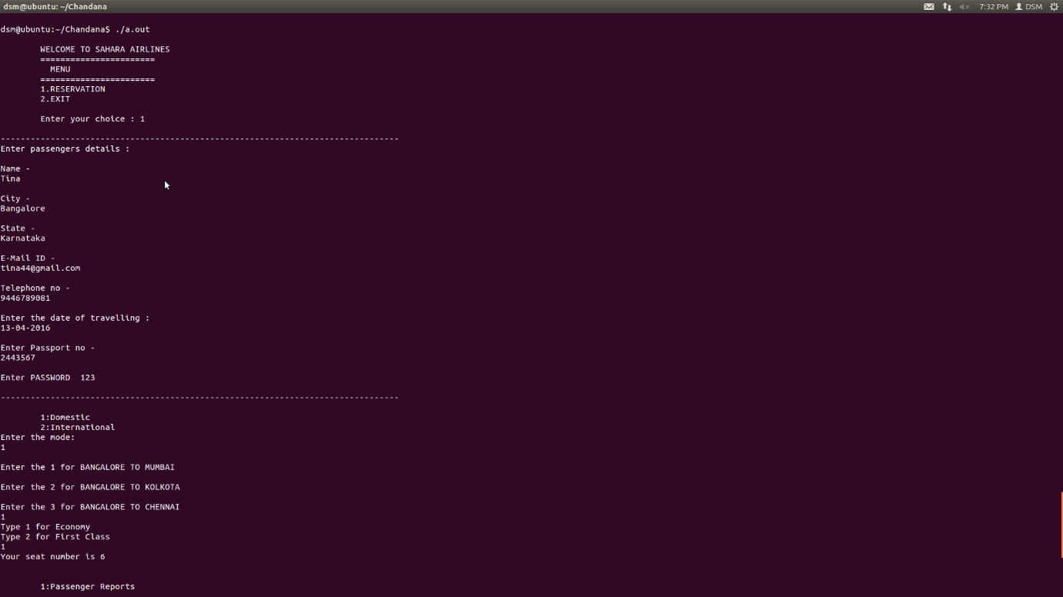

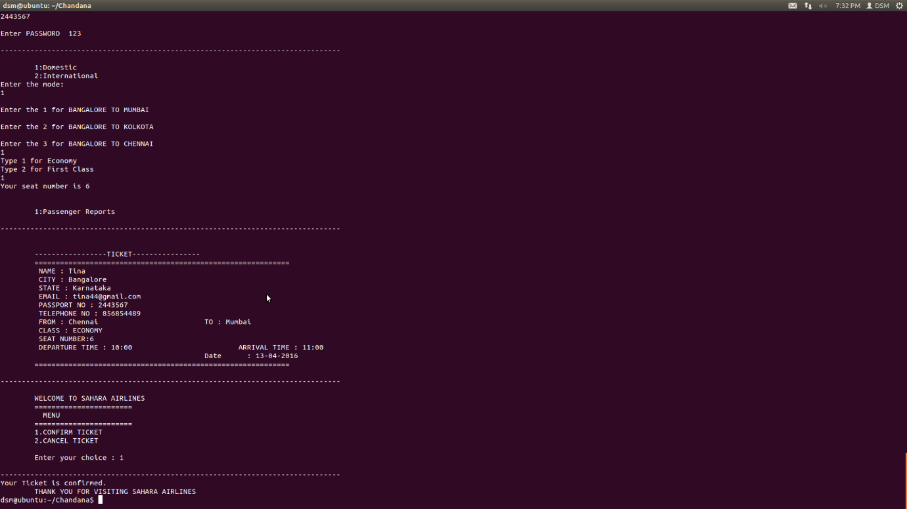

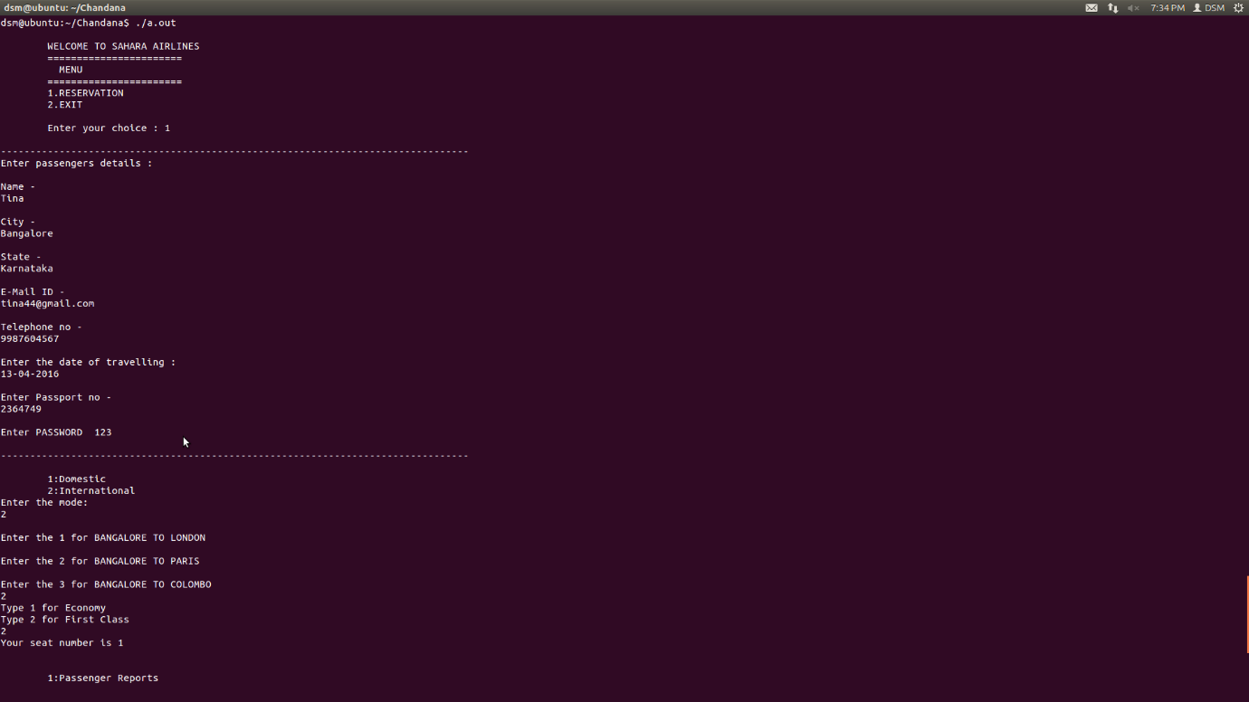

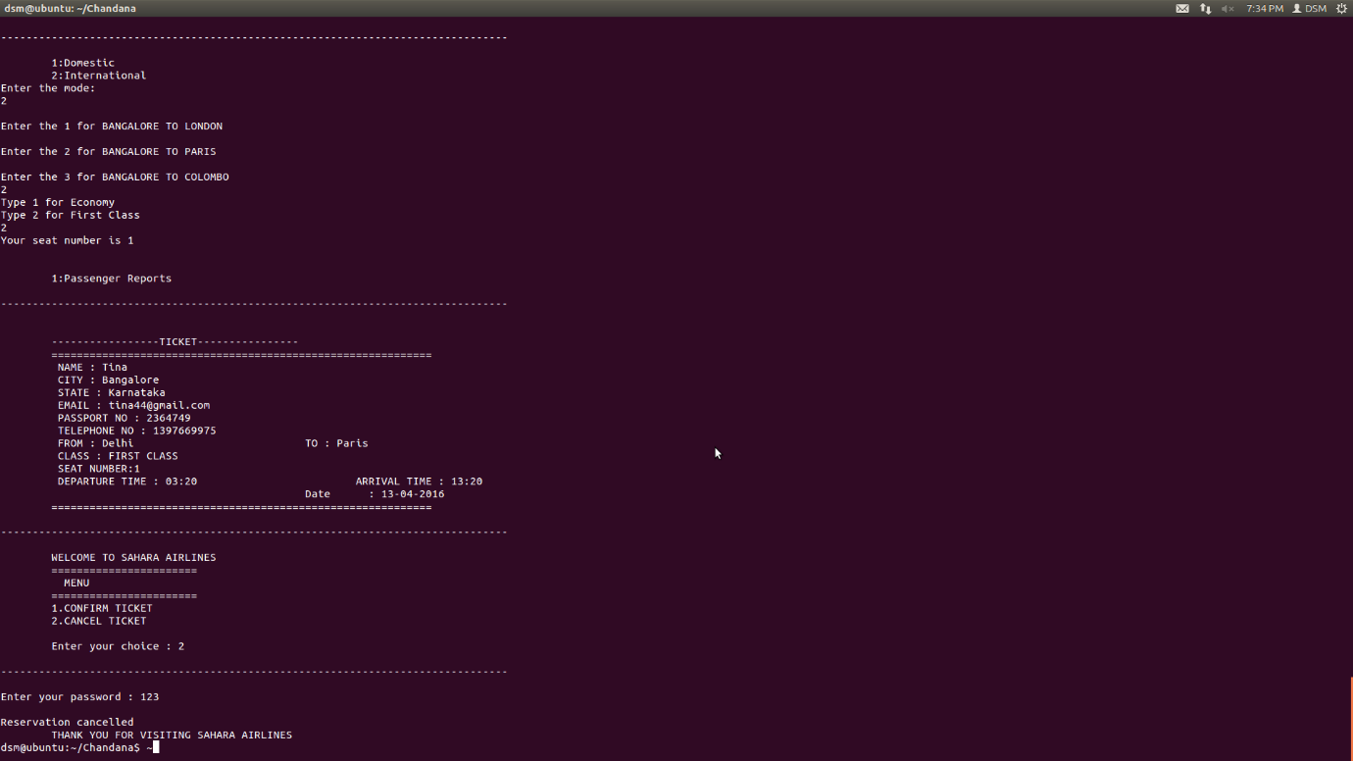

[1]

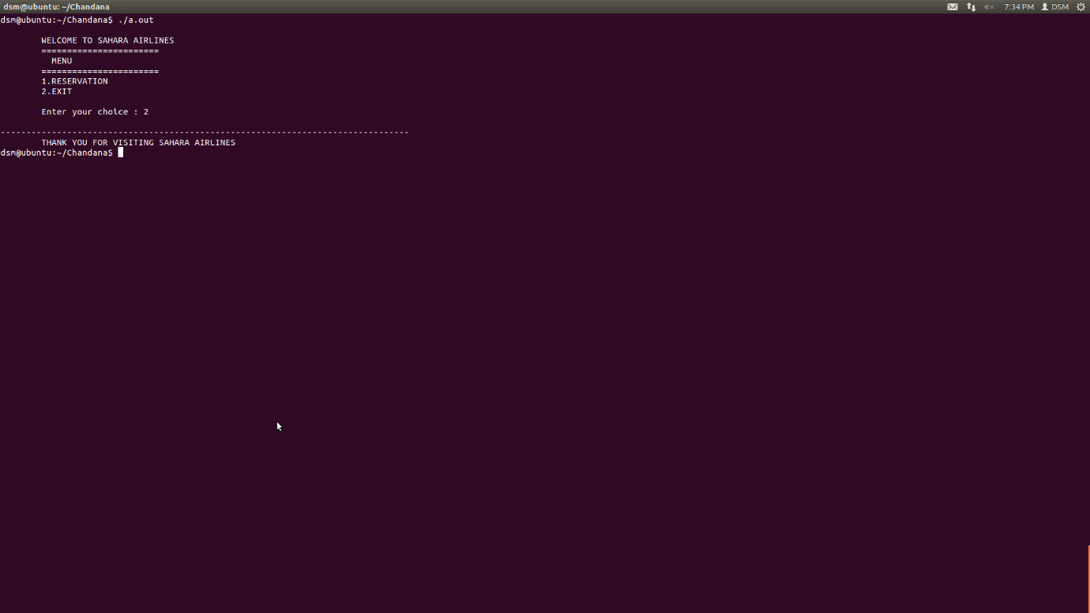

**CONCLUSION**

This Project 'Airline reservation system' aims to model the working of an online airline reservation system. The main purpose of this software is to reduce the manual errors involved in the airline reservation process and make it convenient for the customers to book the flights as when they require such that they can utilize this software to make reservations, modify reservations or cancel a particular reservation.

BIBILOGRAPHY

1. COMPUTER CONCEPTS AND C PROGRAMMING BY VIKAS GUPTA
2. <http://sourcecodernp.blogspot.in/2014/02/airline-reservation-system-in-c.html>
3. <http://www.cplusplus.com/forum/general/54308/>
4. <http://stormprogramming.blogspot.in/2013/10/airline-reservation-system.html>
5. <https://www.experts-exchange.com/questions/20702997/Airline-System-Reservation-using-C-language.html>

1.